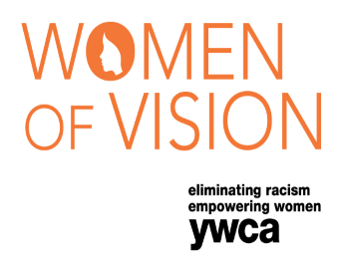

Women of Vision Student Scholarship 2018
YWCA Wausau

The YWCA Wausau is pleased to make available Women of Vision
student scholarships for 2018. Two $500 scholarships will be awarded
in conjunction with our 26th Women of Vision event. Scholarships are
available to women planning to attend a university, college, technical, or
trade school during the 2018-2019 school year. These scholarships are
open to graduating high school seniors, current higher education
students, and nontraditional students. Recipients will be chosen by the
2018 YWCA Women of Vision selection committee.

Scholarship recipients must plan to attend a university, college, technical, or trade school during the 2018-2019 academic year. The scholarship will be paid directly to the school, with $250 awarded the first semester and the additional $250 the second semester. Recipient must provide proof of enrollment.

2018 YWCA Women of Vision Student Scholarship Application

Name of Applicant__________________________________________________________________________________

Permanent Address_________________________________________________________________________________

City___________________ State_______ Zip ____________ Phone ___________________E-Mail ________________

List your community and/or volunteer activities: ________________________________________________________________________________________ ________________________________________________________________________________________________________________________________________________________________________________________________________________________________________________________________________

List honors received and/or activities that demonstrate leadership: ________________________________________________________________________________________
_______________________________________________________________________________________________________________________________________________________________________________________________________________________________________________________________________

Please sign as a commitment to being present to receive your award if selected.

__________________________________________ __________________________
Applicant’s Signature Date

Candidate Essay
Please address the following questions in an essay and attach to this nomination form. Please limit your response to two pages.
- What are your plans for the future?
- Think of a project on which you took the lead. What role did you play? How did you carry out the goals of the project?
- Think of a project that would benefit the needs of the community. What would that project be and how would you implement it?
- How do you intend to have an impact on your community’s quality of life in the future?
- How will your education help you meet your goals?
Please include your high school or college/tech school transcript and no more than three letters of support. Please mail or deliver your entire packet to the YWCA Wausau.

If you have any questions, please contact:
Joann Hendrickson, 715-842-3381 Ext 102, jhendrickson@ywcawausau.org

Please mail or deliver your application no later than April 30, 2018 to:
YWCA Wausau
ATTN: YWCA Women of Vision Student Scholarship 2018
613 N Fifth Street
Wausau, WI 54403

