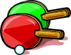
TABLE TENNIS

History
It is not definite as to where and when the game of table tennis originated. The literature show that in Salem, Massachusetts in the 1890’s a sports equipment company, Parker Brothers, developed a game they called INDOOR TENNIS. Because this game received such limited enthusiasm in the United States, Parker Brothers exported the equipment to Hamley Brothers in London, England. The game was warmly received in the British Isles.
In the late 1890’s an unidentified Englishman designed a celluloid ball for use in the game. In the early 1900’s the paddle was covered with rubber and it enabled the players to have a greater control over the ball. As a result of the changes in the ball and paddle, the game gained in popularity among the British.
The Hamley Brothers gave the name ping-pong to the game due to the sound of “pong” when the paddle hit the ball and “ping” when the ball struck the table.
The game lost much of its popularity until the 1920’s when the European countries revived the activity. At this time, the British dropped the name ping-pong and substituted the name table tennis.
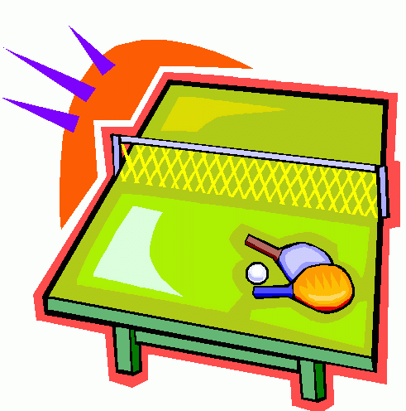

Equipment
The table is a flat rectangular surface 9 feet long and 5 feet wide. The top of the table is a uniform height of 30 inches above the floor. The playing surface has a white line ½ to ¾ inches wide along each edge of the table. The line along the 9-foot side is called the sideline and the line along the 5-foot side is called the end line.
The playing table is divided into two equal courts by a net running parallel to the end lines and at the distance of 4 feet 6 inches from each end line. The net is 6 feet in length and 6 inches high and is suspended across the middle of the table. A centerline is 1/8 to 1/4 inch wide running parallel to the sidelines and midway between them divides the courts into right and left halves.
Today, the ball is made of plastic with a circumference of 4 ½ to 4 ¾ inches. The racket or paddle may be made of any materials, size, shape, or weight.

Rules
The object of the game is to hit the ball with a paddle over the net onto the opposite side of the table so the opponent cannot return it to your side.
To start the game, the server hits the ball with a downward motion so that the ball strikes on your side of the table first and then rebounds across the net and bounces on the other side of the table.

In the single’s game, the serve may hit anywhere on the server’s side of the table and then hit anywhere on the opponents side of the table. One person serves a total of 5 times in a row, either the server or the opponent may score the point. After the server serves 5 times, the opponent serves 5 times in a row. Once again either the server or the opponent may score on the serve. This goes back and forth until one person scores 21 points. If the score is tied at 20-20, the two opponent’s alternate serve until one person wins by 2 points.

In the game of doubles, the serve is always made from the right side of the court, served diagonally to the opponents right side to the court to the same opponent for 5 times. When the ball is rallied back and forth the opponents take turn hitting the ball. For example, Team A1 serves the ball to Team B1, B1 hits the ball back and A2 hits the ball over the net to B2, B2 hits the ball and A1 receives the ball, and the pattern continues as A1, B1, A2, B2, and A1. The ball only hits your side of the table first on a serve then the ball goes over the net. When the ball is received, the ball must bounce first on the table and then hit over the net. Either opponent may score on a serve. When 5 serves are done, the server switch positions with their partner, and the opponent’s person in the right court is the new server. This goes back and forth until one person scores 21 points. If the score is tied at 20-20, the four opponent’s alternate serve until one team wins by 2 points.

Scoring
The first person or team who scores 21 points wins the game. If there is a tie at 20-20, deuce, you alternate servers until one person or team wins by 2 points.

Terminology
Ace – a good serve that the receiver is unable to touch with his paddle
Ad – the abbreviation for advantage
Advantage – the point after deuce
All – a term used to indicate an equal score.
Backspin – a ball hit so that the top of the ball rotates toward the person who hit it
Block Shot – a half volley
Dead Ball – when a let is called, a ball bounces twice on the same side of the table
or at the end of a point
Deuce – the score of 20-20
Doubles – played between two teams of two players
Edge Ball – a ball in play that strikes the top edges or corners of the table. This
ball is counted as good and still in play.
Fault – a service failure in which the ball does not land in the proper court.
Finger Spin – server spins the ball with his fingers when serving. This is illegal.
Let – a service that hits the net but lands in the correct court.
Mixed Doubles – played between 2 teams of a boy and girl partners
Push Shot – a ball is struck in a pushing motion so that there is no spin on it.
Rally – a lengthy exchange of strokes
Singles – played between two players, opponents
Slice – the ball is struck late so that it tends to spin away from the paddle
Top Spin – ball hit so that the top of the ball rotates away from the hitter
Volley – hitting the ball before it has bounced. This is illegal.
